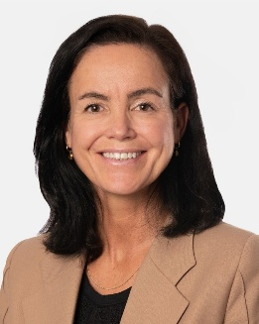  Yvonne van der Laan  Executive Vice President Circular & Low Carbon Solutions  Yvonne van der Laan is responsible for building a scalable circular and lowcarbon- solutions business at LYB. She has over 20 years of experience in the chemical industry, previously holding leadership roles at SABIC, DSM, and the Port of Rotterdam. | 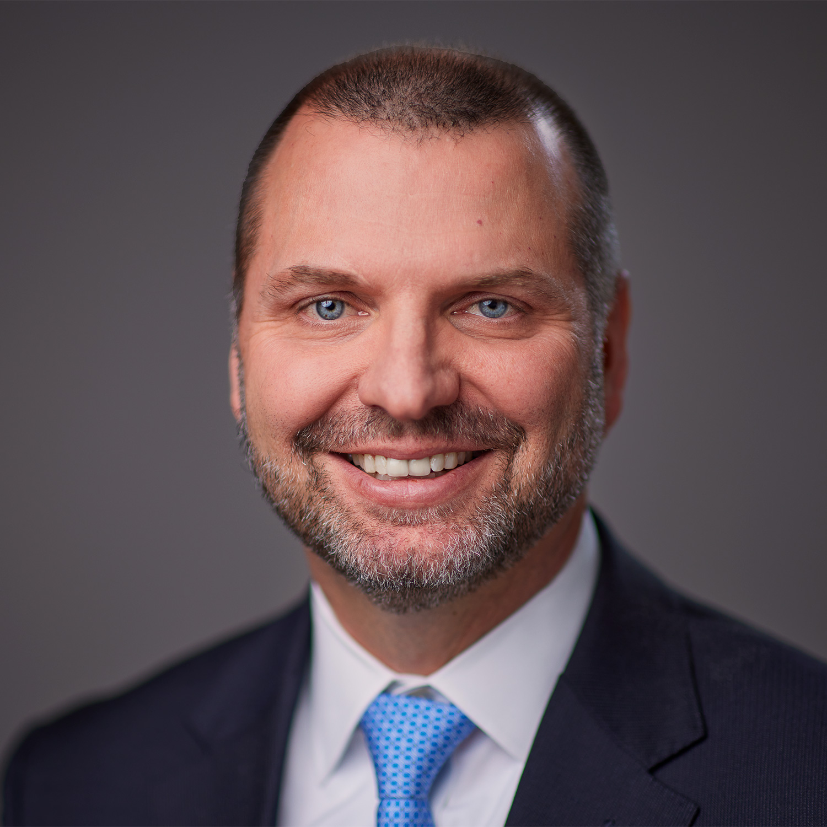  James D. Guilfoyle  Senior Vice President O&P Europe, Asia & International  Jim Guilfoyle oversees manufacturing and commercial operations for Olefins & Polyolefins in Europe, Asia and International markets. He began his career as a chemical engineer in 1993 at Quantum Chemicals and has held various executive roles at LYB.
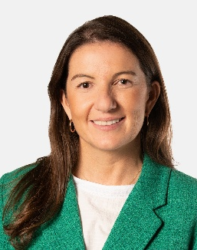  Paula Sanabria  Senior Director EMEAI, Marketing & Commercial Development, Circular & Low Carbon Solutions  Paula and her team are responsible for the marketing and commercial development of the most recent LyondellBasell product family Circulen; driving the growth of the brand and new business models in the market in alignment with the company sustainability strategy and long-term business objectives. | 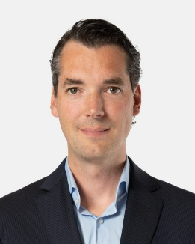  Jaap Rabou  Senior Director Marketing Polyolefins Europe  Jaap Rabou leads marketing strategies for valuable growth at LYB. He has over 19 years of experience in the petrochemical industry.
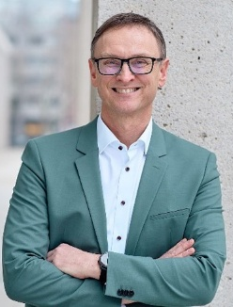  Dr. Erik Licht  New Business Development Director, APS Europe  Erik Licht has been the Director of New Business Development for LYB Advanced Polymer Solutions segment since 2018. With over 22 years of extensive industry experience at LYB, he has held a range of technical and strategic roles. | 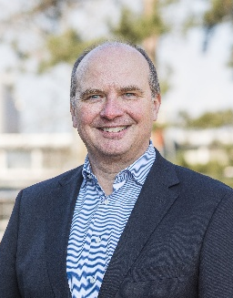  Dr. Daniel Koch  Site Manager Wesseling / Knapsack  Since February 2025, Dr. Daniel Koch has been responsible for managing the largest European LYB production site in Wesseling-Knapsack and serves as Managing Director of Basell Polyolefine GmbH. The PhD chemist brings over 25 years of international experience in the chemical industry and possesses extensive expertise in operational leadership, strategic site development, and the sustainable transformation of industrial processes.

