PIB 37-328 DR300: The newest Hach pocket colorimeter
1024478

Images

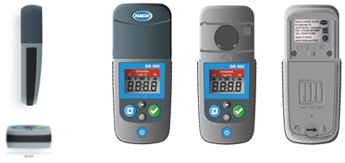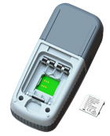

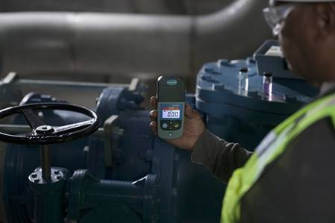

-PRODUCT INFORMATION:
The DR300 models:
The DR300 will support 21 models. Wavelengths included in this line of pocket colorimeters includes 500 nm, 528 nm, 600 nm, and 655 nm. As you can see in the picture below, under each of these wavelengths are the list of parameters that are available. The DR300 series will continue to analyze the most popular and profitable parameters.
The DR900 and Hach Spectrophotometers will be a seller’s resource for customers seeking to keep measuring the obsoleted parameters.

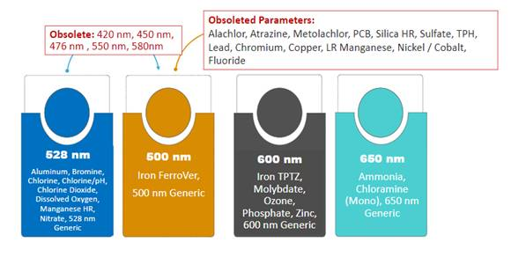

The DR300 is Claros Enabled. Customers can purchase at any time the Bluetooth Hach Communication Dongle.
Claros Collect and the DR300 provide a new level of ease for operators and managers in distribution and water systems by; preventing data transcription errors, ensuring accountability, providing measurement traceability, and improving efficiency and time saving for customers manually entering data using pen and paper.
The Bluetooth Hach Communication dongle and Claros Collect will be available for sale with the DR300 in the U.S., Canada and Europe ONLY
To view the full PIB, please sign into your account.

-CALLS TO ACTION FOR THE SALES CHANNEL:
- Review the E-Learning for the DR300:
https://www2.virtualtrainingassistant.com/Hach/LearnerConnection/Menu8.aspx?&Page=crsedesc&Continue=cCrseSearch&Site=00&Area=PDT&Subj=LBP&Crse=110
- Offer the DR300 pocket colorimeter as the successor for the Pocket Colorimeter II.
-CALLS TO ACTION FOR THE SERVICE CHANNEL:
- Inform your customers about the new service products for the DR300 Colorimeter
- Start offering the new service products along with any new DR300 Colorimeter
- Consider the ProtectionPlus Plan for any new DR300 Colorimeter
-COMMUNICATION TO CUSTOMERS:
- The Hach DR300 Pocket Colorimeter is the next generation in portable instrumentation.
- The DR300 maintains the Pocket Colorimeter legacy of reliability while providing state-of-the-art data while providing state-of-the-art improvements and connection to Claros.
- Reduce data collection hassles.
- Eliminate transcription errors.
- Ensure stronger compliance traceability.

Product Table:

Products:
Part Number US | Part Number EU | Description
LPV445.97.00110 | LPV445.99.00110 | DR300 - Chlorine,Free+Total, w.Box  Pocket Colorimeter
LPV445.97.01110 | LPV445.99.01110 | DR300 - Bromine, w. Box  Pocket Colorimeter
LPV445.97.02110 | LPV445.99.02110 | DR300 - Nitrate, w. Box  Pocket Colorimeter
LPV445.97.03110 | LPV445.99.03110 | DR300 - Dissolved Oxygen, w. Box  Pocket Colorimeter
LPV445.97.04110 | LPV445.99.04110 | DR300 - Ozone, w. Box  Pocket Colorimeter
LPV445.97.06110 | LPV445.99.06110 | DR300 - Phosphate, w. Box  Pocket Colorimeter
LPV445.97.09110 | LPV445.99.09110 | DR300 - Zinc, w. Box  Pocket Colorimeter
LPV445.97.10110 | LPV445.99.10110 | DR300 - Molybdenum, LR/HR, w.Box  Pocket Colorimeter
LPV445.97.12110 | LPV445.99.12110 | DR300 - Chlorine & pH, w. Box  Pocket Colorimeter
LPV445.97.15110 | LPV445.99.15110 | DR300 - Manganese, w. Box, HR  Pocket Colorimeter
LPV445.97.16110 | LPV445.99.16110 | DR300 - Iron, TPTZ, w. Box  Pocket Colorimeter
LPV445.97.22110 | LPV445.99.22110 | DR300 - Iron, FerroVer, w. Box  Pocket Colorimeter
LPV445.97.25110 | LPV445.99.25110 | DR300 - Aluminum, w. Box  Pocket Colorimeter
PV445.97.26110 | LPV445.99.26110 | DR300 - Monochlor/Free NH3, w. Box  Pocket Colorimeter
LPV445.97.40110 | LPV445.99.40110 | DR300 - Ammonia Nitrogen, w. Box  Pocket Colorimeter
LPV445.97.50110 | LPV445.99.50110 | DR300 - 500 nm, w. Box  Pocket Colorimeter
LPV445.97.51110 | LPV445.99.51110 | DR300 - Chlorine Dioxide, w. Box  Pocket Colorimeter
LPV445.97.52110 | LPV445.99.52110 | DR300 - 528 nm, w. Box  Pocket Colorimeter
LPV445.97.60110 | LPV445.99.60110 | DR300 - 600 nm, w. Box  Pocket Colorimeter
LPV445.97.62110 | LPV445.99.62110 | DR300 - Cl, Free+Total, MR, w.Box  Pocket Colorimeter
LPV445.97.65110 | LPV445.99.65110 | DR300 - 655 nm, w. Box  Pocket Colorimeter
 | LPV446.99.00012 | HCD (Hach Communication Dongle)
Service:
Part Number US | Part Number EU | Description
S-X5PPP-DR300 | S-X5PPP-DR300 | 5-Year ProtectionPlus Plan
BSPDR300 | - | Bench Service Partnership
BSPPLUSDR300 | - | BenchPlus Service Partnership
BCPDR300 | - | Bench Calibration Partnership
PMP-DR300-1V | - | Preventative Maintenance Partnership  1 visit per year
PMP-DR300-2V | - | Preventative Maintenance Partnership  2 visits per year
PMP-DR300-4V | - | Preventative Maintenance Partnership  4 visits per year
- | S-FIEX1-DR300 | Field Service for Verification
- | S-CENP1-DR300 | Central Plus Service

-TECHNICAL SUPPORT: Frequently Asked Questions
Q. Can the Hach Communication Dongle be purchased separately?
A. Yes, our customers have the flexibility to purchase the DR300 first and then the Dongle when they are ready to try our Claros Collect solution.
Q. Apart from the BT connectivity, is there any other way to transfer data to a PC?
A. Bluetooth is the only available option to transfer Data digitally.
Q. Is there the option to run LCK and TNTplus on the DR300?
A. No, this won’t be available with the DR300.
Q. What has changed from the Pocket Colorimeter II to the DR300?
A. These are the main design improvements:
- New Hach visual appearance
- Bigger, better display
- Brighter backlight
- Waterproof instrument IP67 (Even better than PCII)
- Optimized user-friendly menu to change from LR to HR
- Data connectivity enabled Bluetooth to Claros (optional by purchasing the Bluetooth dongle). U.S., Canada, and EU ONLY.
- Claros Mobile phone app is available for the DR300. U.S., Canada and EU ONLY.
Q. How long will Hach continue supporting the PC II colorimeter?
A. Hach will continue supporting the PC II colorimeter for at least 5 years after its obsolescence.
Q. What does the ProtectionPlus Plan (PPP) include?
A. The ProtectionPlus Plan is a new service offering, which provides five years of full coverage for repairs at the Hach Service Center for a small fraction of the cost of replacing the instrument. This is a non-renewable contract, similar to an extended warranty, that is purchased at the point of sale. Additional details on this new program will be made available in a separate PIB prior to launch.
Q. What does the Bench Calibration Partnership for North America include?
A. This is another new service offering, which is a contract that only includes annual calibration and certification at the Hach Service Center. This is a renewable contract that benefits customers who are not interested in repair coverage, but are required to have their instrument calibrated and certified every year. Additional details on this new program will be made available in a separate PIB prior to launch.
Q. What is included in all of the other service offerings?
A. These service products are structured in the same way as the current portfolios in Europe (known as “Service 2.0”) and North America (Service Partnerships). Please refer to the standard documentation for specific coverage information. Additional details on all of the service options available for the DR300 will be included in a separate PIB prior to launch.
Q. Do we also have TSE service numbers for the new DR300 in Europe?
A. No, the new service products only come with new service items numbers (also known as “Service 2.0”).
-INTERNATIONAL SUPPORT: Contact Hach International at intl@hach.com

