**Instructions to Access Chamberlain University**

**CITI Human Subjects Research Programs**

**New Users:**

Step 1: Log into <https://www.citiprogram.org>

Step 2: If a new user, click on the “Register” tab

Step 3: Go to the “Select Your Organization Affiliation” Tab and type in Chamberlain University:

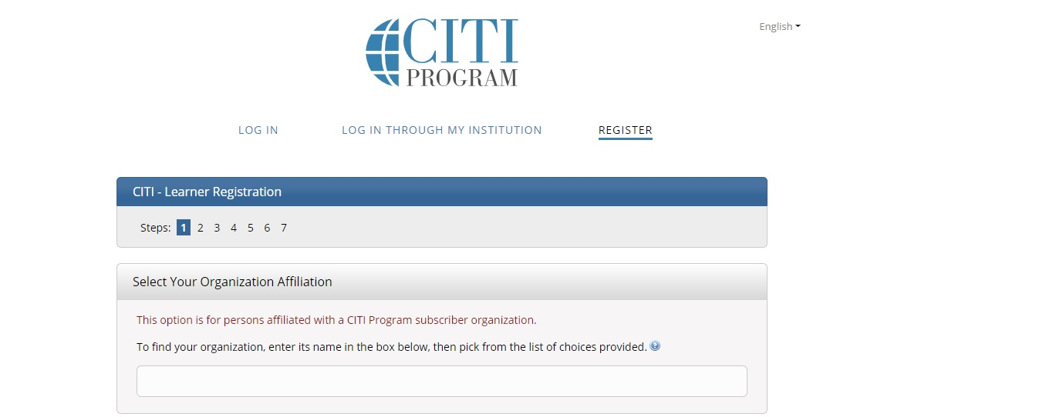

Step 4: Check the box marked “I agree to Terms of Service…..” and “I affirm that I am an affiliate of Chamberlain University.” (This will allow you to enroll in the Chamberlain course at no charge..) Then click “Create a CITI Program Account”

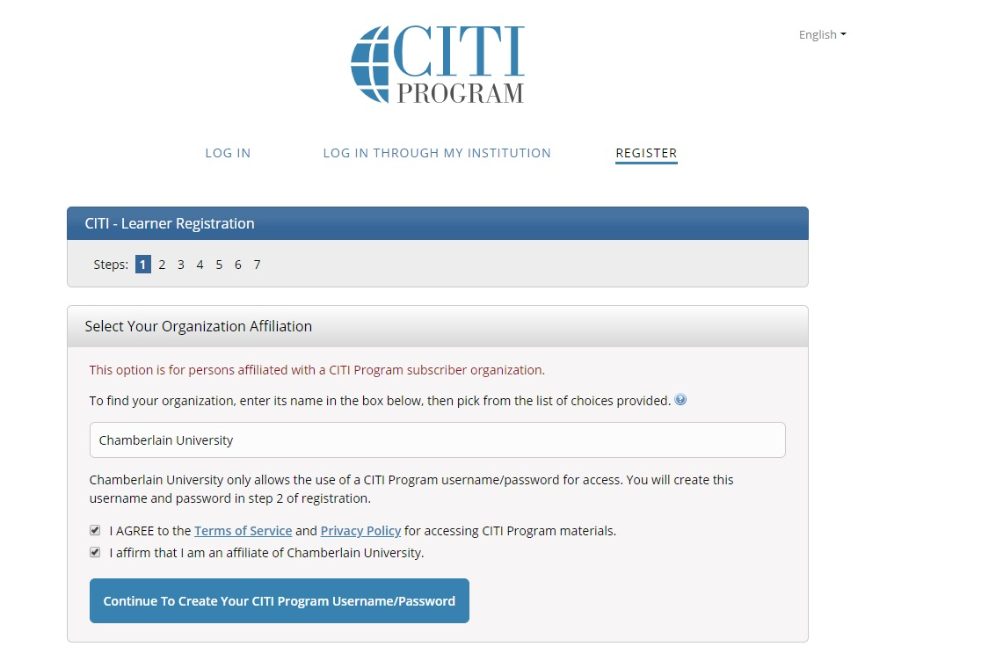

Step 5: Type in your personal information on the Learner Registration page, then click the “Continue” tab at the bottom of the page.

Step 6: Fill in the information to create a username, password, and security questions, then click the “Continue” tab at the bottom of the page.

Step 7: Type in your country of residence, then click the “Finalize Registration” tab at the bottom of the page.

Step 8: Indicate whether or not you wish to obtain CE credits for the course. Please note: If you say “Yes,” you will be charged a fee. Then click “Submit” at the bottom of the page.

Step 9: Please complete the Learner Registration Information. For Chamberlain students and employees, please type in your D number for “Employee Number”, otherwise, please leave blank.

For “Role in Research”, you may have several roles. Please select just one. Students should always select “Student Researcher” and the appropriate level. Then click “Continue” at the bottom of the page.

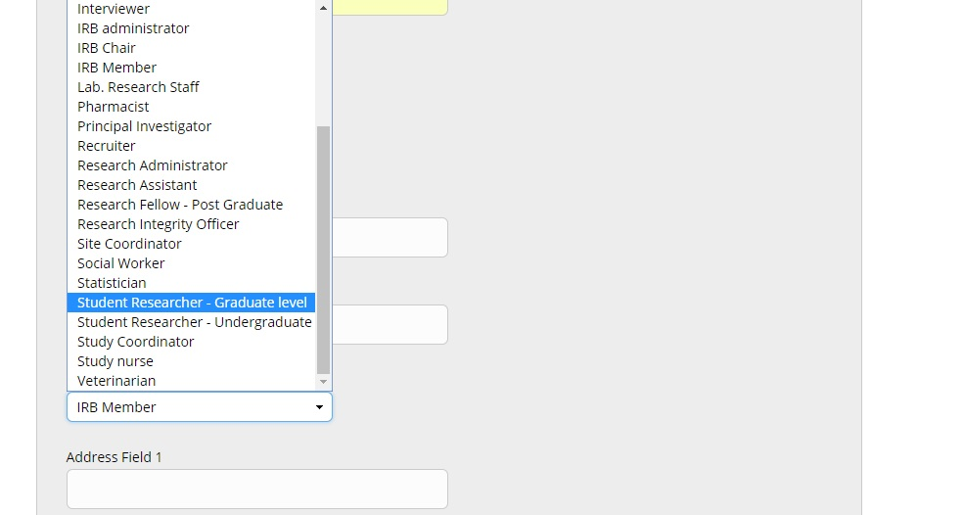

Step 10: Select the Human Subjects Research course you wish to take in the field titled “Question 1”. Select either the Biomedical Research Investigators or the Social & Behavioral Research Investigators course. Your course selection should correspond to the type of research you plan to conduct. This question requests one answer only; however, you can always add another course later if you conduct both types of research. Once you’ve selected the course, click “Submit.”

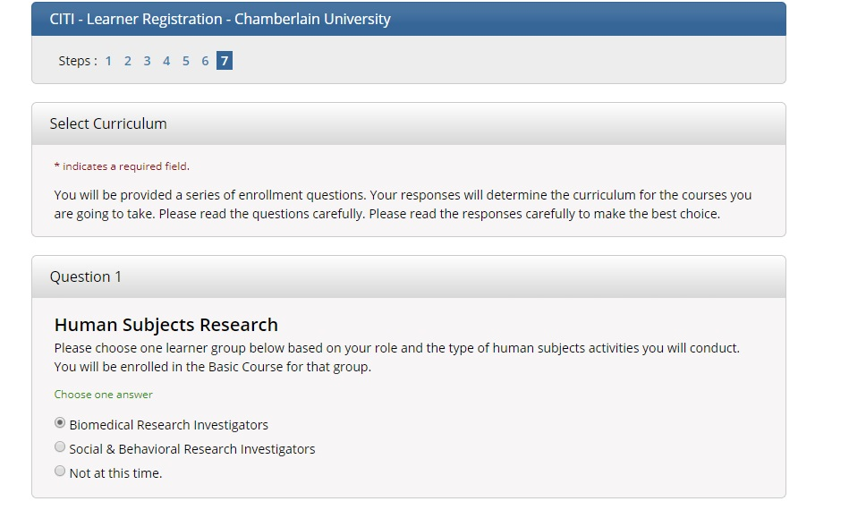

Step 11: You can now access your course by clicking “Start Now” in the field containing your course title. Otherwise, click on the “Chamberlain University Courses” tab to pull up a drop-down menu. You should see your course as well as some additional actions. To access the course, click on the title of your course.

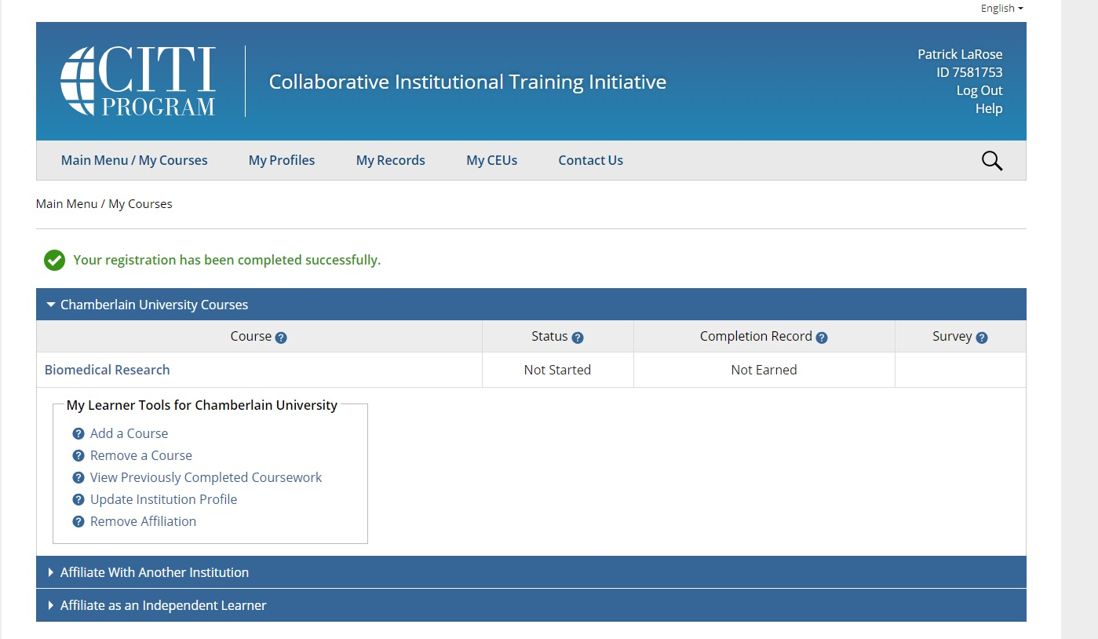

Step 12: After you have clicked on the link to your course, you will be asked to complete an assurance of integrity statement. Click on the “Complete The Integrity Assurance Statement….” Tab. Click on :”Agree” and then “Submit”.

Step 13: The modules for your course will now appear and be accessible. The course requires that you complete the modules in a certain sequence. The modules available for access will be in blue font as a hyperlink. When you complete a module, at the bottom of the page, you will be asked to complete the quiz. You must earn an 80% on all modules to successfully complete the course. You will be able to print up a transcript and certificate upon completion of the course.

**Existing Users**

Step 1: Access CITI at <https://www.citiprogram.org> and log in using your existing username and password.

Step 2: Click on “My Profiles” to update any new information.

Step 2: Click on the “View Courses” tab next to “Chamberlain University.” Select the course you wish to continue or start and follow the instructions.