Does this evidence answer the EBP question? | ☐ Yes → Continue appraisal  ☐ No → STOP, do not continue evidence appraisal
Article Summary Information
Article Title:Click or tap here to enter text.

Author(s):Click or tap here to enter text. |  | Number:Click or tap here to enter text.
Population, size, and setting: Click or tap here to enter text. |  | Publication date:Click or tap here to enter text.
Complete after appraisal
Evidence level and quality rating: Click or tap here to enter text.
Study findings that help answer the EBP question:Click or tap here to enter text.

Article Appraisal Workflow
Is this study:
☐ QuaNtitative (collection, analysis, and reporting of numerical data)
Numerical data (how many, how much, or how often) are used to formulate facts, uncover patterns, and generalize to a larger population; provides observed effects of a program, problem, or condition. Common methods are polls, surveys, observations, and reviews of records or documents. Data are analyzed using statistical tests.
- Go to Section I for QuaNtitative leveling

☐ QuaLitative (collection, analysis, and reporting of narrative data)
Rich narrative data to gain a deep understanding of phenomena, meanings, perceptions, concepts, and experiences from those experiencing it. Sample sizes are relatively small and determined by the point of redundancy when no new information is gleaned, and key themes are reiterated (data saturation). Data are analyzed using thematic analysis. Often a starting point for studies when little research exists; may use results to design empirical studies. Common methods are focus groups, individual interviews (unstructured or semi-structured), and participation/observations.
- Go to Section II for QuaLitative leveling

☐ Mixed methods (results reported both numerically and narratively)
A study design (a single study or series of studies) that uses rigorous procedures in collecting and analyzing both quaNtitative and quaLitative data. Note: QuaNtitative survey designs with open-ended questions do not meet criteria for mixed methods research because those questions are not approached using strict quaLitative methods. Mixed methods studies provide a better understanding of research problems than using either a quaNtitative or quaLitative approach alone.
- Go to Section III for Mixed Methods leveling

Section I: QuaNtitative Appraisal
A  Is this a report of a single research study? |  |  | Yes → Continue to decision tree  No → Go to Section I: B
Level | 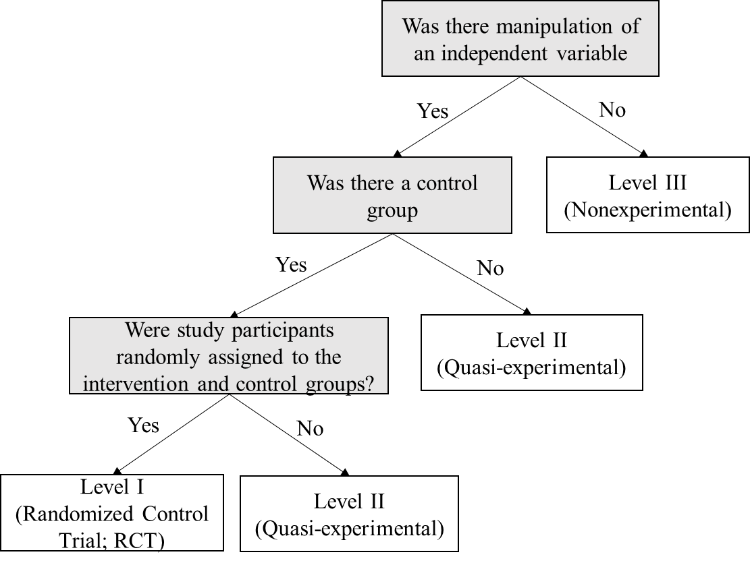  Level I studies include randomized control trials (RCTs) or experimental studies  Level II studies have some degree of investigator control and some manipulation of an independent variable but lack random assignment to groups and may not have a control group  Level III studies lack manipulation of an independent variable; can be descriptive, comparative, or correlational; and often use secondary data
Quality | After determining the level of evidence, determine the quality of evidence using the considerations below:
 | Does the researcher identify what is known and not known about the problem? |  |  | ☐Yes | ☐ No
 | Does the researcher identify how the study will address any gaps in knowledge? |  |  | ☐ Yes | ☐ No
 | Was the purpose of the study clearly presented? |  |  | ☐ Yes | ☐ No
 | Was the literature review current (most sources within the past five years or a seminal study)? |  |  | ☐ Yes | ☐ No
 | Was sample size sufficient based on study design and rationale? |  |  | ☐ Yes | ☐ No
 | If there is a control group:  - Were the characteristics and/or demographics similar in both the control and intervention groups?  - If multiple settings were used, were the settings similar?  - Were all groups equally treated except for the intervention group(s)? |  |  | ☐ Yes  ☐ Yes  ☐ Yes | ☐ No  ☐ No  ☐ No | ☐ N/A  ☐ N/A  ☐ N/A
 | Are data collection methods described clearly? |  |  | ☐ Yes | ☐ No
 | Were the instruments reliable (Cronbach’s α [alpha] > 0.70)? |  |  | ☐ Yes | ☐ No | ☐ N/A
 | Was instrument validity discussed? |  |  | ☐ Yes | ☐ No | ☐ N/A
 | If surveys or questionnaires were used, was the response rate > 25%? |  |  | ☐ Yes | ☐ No | ☐ N/A
 | Were the results presented clearly? |  |  | ☐ Yes | ☐ No
 | If tables were presented, was the narrative consistent with the table content? |  |  | ☐ Yes | ☐ No | ☐ N/A
 | Were study limitations identified and addressed? |  |  | ☐ Yes | ☐ No
 | Were conclusions based on results? |  |  | ☐ Yes | ☐ No
Section I: QuaNtitative Appraisal (continued)
Quality |  | Select the appropriate quality rating below:
☐ A High quality: Consistent, generalizable results; sufficient sample size for the study design; adequate control; definitive conclusions; consistent recommendations based on comprehensive literature review that includes thorough reference to scientific evidence.

☐ B Good quality: Reasonably consistent results; sufficient sample size for the study design; some control; fairly definitive conclusions; reasonably consistent recommendations based on fairly comprehensive literature review that includes some reference to scientific evidence.

☐ C Low quality: Little evidence with inconsistent results; insufficient sample size for the study design; conclusions cannot be drawn.
Record findings that help answer the EBP question on page 1

Section I: QuaNtitative Appraisal (continued)
B  Is this a summary of multiple sources of research evidence? |  | ☐ Yes → Continue to decision tree  ☐ No → Use the Nonresearch Evidence Appraisal tool (Appendix F)
Level | 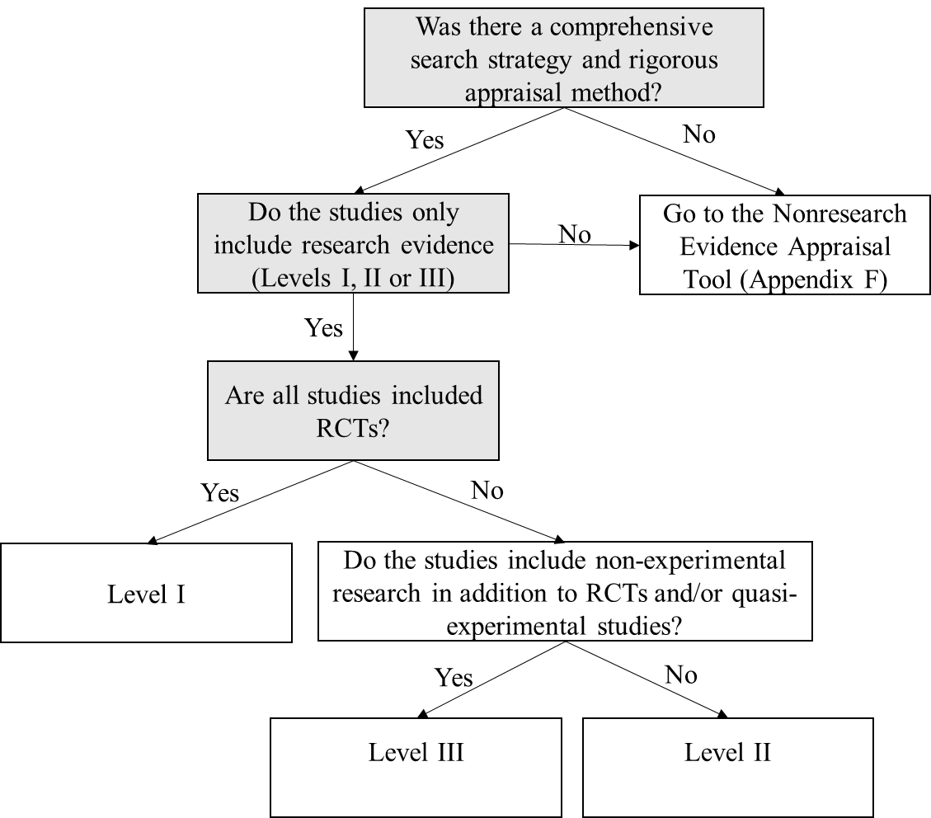
Quality | After determining level of evidence, determine the quality of evidence using the considerations below:
 | Were the variables of interest clearly identified? | ☐ Yes | ☐ No
 | Was the search comprehensive and reproducible?  - Key terms stated  - Multiple databases searched and identified  - Inclusion and exclusion criteria stated | ☐ Yes  ☐ Yes  ☐ Yes | ☐ No  ☐ No  ☐ No
 | Was there a flow diagram that included the number of studies eliminated at each level of review? | ☐ Yes | ☐ No
 | Were details of included studies presented (design, sample, methods, results, outcomes, strengths, and limitations)? | ☐ Yes | ☐ No
 | Were methods for appraising the strength of evidence (level and quality) described? | ☐ Yes | ☐ No
 | Were conclusions based on results?  - Results were interpreted  - Conclusions flowed logically from the research question, results, and interpretation | ☐ Yes  ☐ Yes | ☐ No  ☐ No
 | Did the systematic review include a section addressing limitations and how they were addressed? | ☐ Yes | ☐ No
Section I: QuaNtitative Appraisal (continued)
Quality | Select the appropriate quality rating below:
☐ A High quality: Consistent, generalizable results; sufficient sample size for the study design; adequate control; definitive conclusions; recommendations consistent with the study’s findings and include thorough reference to scientific evidence

☐ B Good quality: Reasonably consistent results; sufficient sample size for the study design; some control; fairly definitive conclusions; recommendations reasonably consistent recommendations based on with athe study’s findings and fairly comprehensive evidence appraisal (vs literature review?) that includes some reference to scientific evidence

☐ C Low quality: Little evidence with inconsistent results; insufficient sample size for the study design; conclusions cannot be drawn.

Record findings that help answer the EBP question on page 1

Section II: QuaLitative Appraisal
A  Is this a report of a single research study? |  | ☐ Yes → This is Level III evidence  ☐ No → Go to Section II: B
 | After determining level of evidence, determine the quality of evidence using the considerations below:
Quality | Was there a clearly identifiable and articulated:  - Purpose?  - Research question?  - Justification for design and/or theoretical framework used? |  | ☐Yes  ☐Yes  ☐Yes | ☐ No  ☐No  ☐No
 | Do participants have knowledge of the subject the researchers are trying to explore? |  | ☐Yes | ☐ No
 | Were characteristics of study participants described? |  | ☐Yes | ☐ No
 | Was a verification process used in every step of data analysis (e.g., triangulation, response validation, independent double check, member checking)? (Credibility) |  | ☐Yes | ☐ No
 | Does the researcher provide sufficient documentation of their thinking, decisions, and methods related to the study allowing the reader to follow their decision-making (e.g., how themes and categories were formulated)? (Confirmability) |  | ☐Yes | ☐ No
 | Does the researcher provide an accurate and rich description of findings by providing the information necessary to evaluate the analysis of data? (Fittingness) |  | ☐Yes | ☐ No
 | Does the researcher acknowledge and/or address their own role and potential influence during data collection? |  | ☐Yes | ☐ No
 | Was sampling adequate, as evidenced by achieving data saturation? |  | ☐Yes | ☐ No
 | Does the researcher provide illustrations from the data?  - If yes, do the provided illustrations support conclusions? |  | ☐Yes  ☐Yes | ☐ No  ☐ No
 | Is there congruency between the findings and the data? |  | ☐Yes | ☐ No
 | Is there congruency between the research methodology and:  - The research question(s)  - Between methods to collect data  - The interpretation of results |  | ☐Yes  ☐Yes  ☐Yes | ☐ No  ☐ No  ☐ No
 | Are discussion and conclusions congruent with the purpose and objectives, and supported by literature? |  | ☐Yes | ☐ No
 | Are conclusions drawn based on the data collected (e.g., the product of the observations or interviews)? |  | ☐Yes | ☐ No

 | Section II: QuaLitative Appraisal (continued)
Quality | Select the appropriate quality rating below:
☐ A/B High/Good Quality: The report discusses efforts to enhance or evaluate the quality of the data and the overall inquiry in sufficient detail; it describes the specific techniques used to enhance the quality of the inquiry.

Evidence of at least half or all the following is found in the report:

- Transparency: Describes how information was documented to justify decisions, how data were reviewed by others, and how themes and categories were formulated.
- Diligence: Reads and rereads data to check interpretations; seeks opportunity to find multiple sources to corroborate evidence.
- Verification: The process of checking, confirming, and ensuring methodologic coherence.
- Self-reflection and self-scrutiny: Being continuously aware of how a researcher’s experiences, background, or prejudices might shape and bias analysis and interpretations.
- Participant-driven inquiry: Participants shape the scope and breadth of questions; analysis and interpretation give voice to those who participated.
- Insightful interpretation: Data and knowledge are linked in meaningful ways to relevant literature.

☐ C Low quality: Lack of clarity and coherence of reporting, lack of transparency in reporting methods; poor interpretation of data and offers little insight into the phenomena of interest; few, if any, of the features listed for high/good quality.

Record findings that help answer the EBP question on page 1

Section II: QuaLitative Appraisal
Is this a summary of multiple sources of qualitative research evidence with a comprehensive search strategy and rigorous appraisal method (Meta-synthesis)?  B |  | ☐ Yes → This is Level III  Evidence  ☐ No→ Go to Section II: B
Quality | After determining level of evidence, determine the quality of evidence using the considerations below:
 | Were the search strategy and criteria for selecting primary studies clearly defined? |  | ☐Yes | ☐ No
 | Was there a description of a systematic and thorough process for how data were analyzed? |  | ☐Yes | ☐ No
 | - Were methods described for comparing findings from each study? |  | ☐Yes | ☐ No
 | - Were methods described for interpreting data? |  | ☐Yes | ☐ No
 | - Was sufficient data presented to support the interpretations? |  | ☐Yes | ☐ No
 | Did synthesis reflect:  - New insights?  - Discovery of essential features of the phenomena?  - A fuller understanding of the phenomena? |  | ☐Yes  ☐Yes  ☐Yes | ☐ No  ☐ No  ☐ No
 | Are findings clearly linked to and match the data? |  | ☐Yes | ☐ No
 | Are findings connected to the purpose, data collection, and analysis? |  | ☐Yes | ☐ No
 | Are discussion and conclusions connected to the purpose, objectives, and (if possible) supported by literature? |  | ☐Yes | ☐ No
 | Did authors describe clearly how they arrived at the interpretation of the findings? |  | ☐Yes | ☐ No
 | Select the appropriate quality rating below:
☐ A/B High/Good Quality: The report discusses efforts to enhance or evaluate the quality of the data and the overall inquiry in sufficient detail; and it describes the specific techniques used to enhance the quality of the inquiry.
Evidence of some or all of the following is found in the report:
- Transparency: Describes how information was documented to justify decisions, how data were reviewed by others, and how themes and categories were formulated.
- Diligence: Reads and rereads data to check interpretations; seeks opportunity to find multiple sources to corroborate evidence.
- Verification: The process of checking, confirming, and ensuring methodologic coherence.
- Self-reflection and self-scrutiny: Being continuously aware of how a researcher’s experiences, background, or prejudices might shape and bias analysis and interpretations.
- Participant-driven inquiry: Participants shape the scope and breadth of questions; analysis and interpretation give voice to those who participated.
- Insightful interpretation: Data and knowledge are linked in meaningful ways to relevant literature.

☐ C Low quality: Lack of clarity and coherence of reporting, lack of transparency in reporting methods; poor interpretation of data and offers little insight into the phenomena of interest; few, if any of the features listed for high/good quality.
Record findings that help answer the EBP question on page 1

Section III: Mixed Methods Appraisal
You will need to appraise both parts of the study independently before appraising the study as a whole. Evaluate the quaNtitative part of the study using Section I. Evaluate the qualitative part of the studying using Section II, then return here to complete appraisal.

Level |  | Level |  | Quality
 | QuaNtitative Portion | Click or tap here to enter text. |  | Click or tap here to enter text.
 | QuaLitative Portion | Click or tap here to enter text. |  | Click or tap here to enter text.
The level of mixed methods evidence is based on the sequence of data collection. Quantitative data collection followed by quaLitative (explanatory design) is based on the level of the quaNtitative portion. All other designs (exploratory, convergent, or multiphasic) are Level III evidence.

Explanatory sequential designs collected quantitative data first, followed by qualitative.
Exploratory sequential designs collect qualitative data first, followed by quantitative.
Convergent parallel designs collect quantitative and qualitative data at the same time.
Multiphasic designs collect qualitative and quantitative data over more than one phase.
Quality | After determining the level of evidence, determine the quality of evidence using the considerations below:
 | Was the mixed-methods research design relevant to address both quaNtitative and quaLitative research questions (or objectives)? |  | ☐Yes |  | ☐ No
 | Was the research design relevant to address the quaNtitative and the quaLitative aspects of the mixed-methods question (or objective)? |  | ☐Yes |  | ☐ No
 | Select the appropriate quality rating below:
☐ A High quality: Contains high-quality quaNtitative and quaLitative study components; highly relevant study design; relevant integration of data or results; and careful consideration of the limitations of the chosen approach.

☐ B Good quality: Contains good-quality quaNtitative and quaLitative study components; relevant study design; moderately relevant integration of data or results; and some discussion of limitations of integration.

☐ C Low quality: Contains low quality quaNtitative and quaLitative study components; study design not relevant to research questions or objectives; poorly integrated data or results; and no consideration of limits of integration.
Record findings that help answer the EBP question on page 1

