Canva Job Aid
- Click on the infographic template
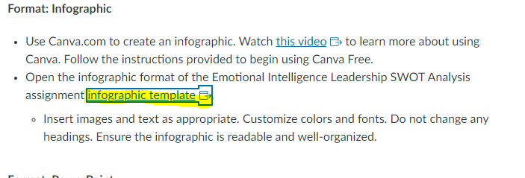
This will take you to Canva where you will see this:
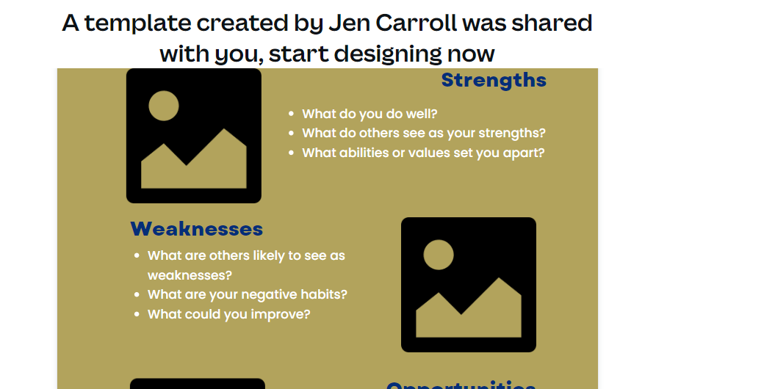

*please note that Jen Caroll is the instructional designer who created the template, that is why you see a name there.

- Scroll to the bottom of the page and click here:

- Next, it will go to this screen where you will need to sign up for an account (it is free)
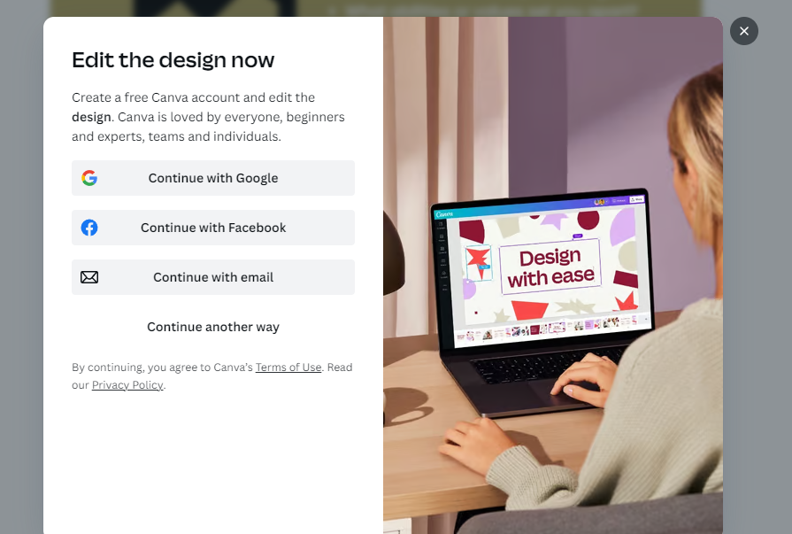

- Once you have created your account, you will be able to edit the infographic template:
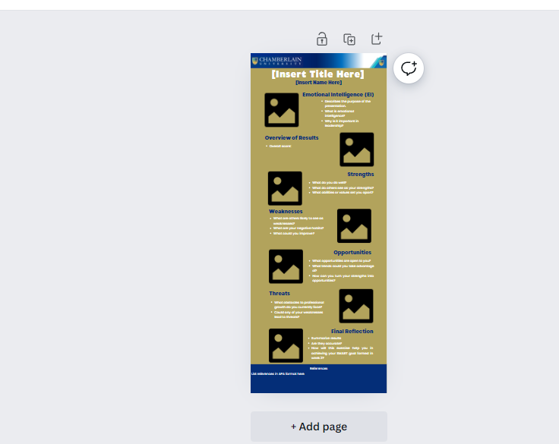
- You will want to zoom in so that the font is larger and easier to modify:
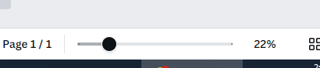

- Double-click in the boxes to make the edits, and the boxes will move. You can modify it however it looks best. You will likely need to change the font size.

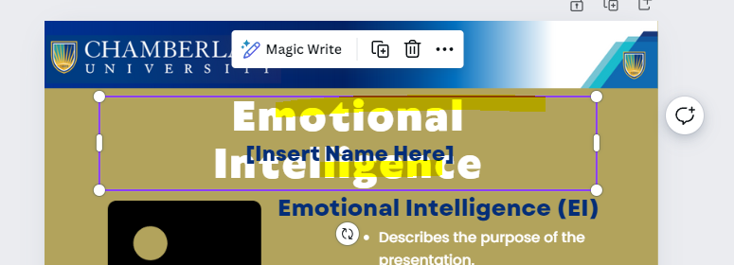
- Highlight the words that you want to change size

- Then go to this area to select size, font, etc.

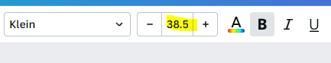
- Once you have completed the assignment, including all information you will want to save it.
- To save, go to Share:
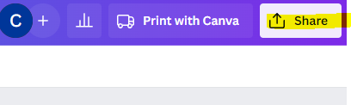
- Then choose Download.
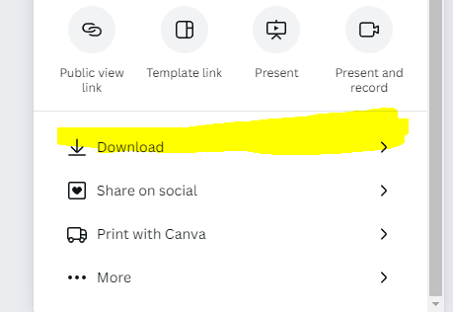

- Select “Print”
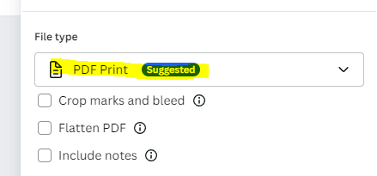
- Then it will show up here in your downloaded files (this may vary depending on browser):
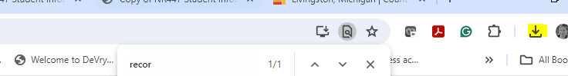

- Open the pdf, choose the down arrow to save it:
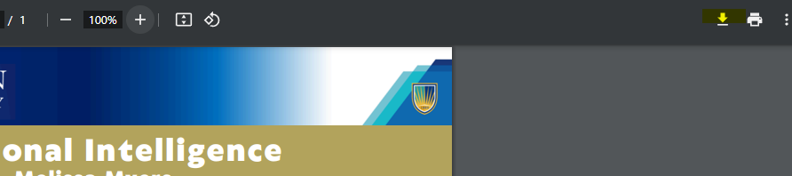

- Then save to your files

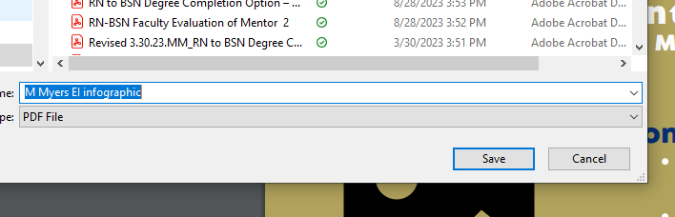
- Lastly, submit to the assignment area.

Play around with it and have fun!

