# The i-Human Welcome Page

Click **Let’s Get Started** to access the Getting Started! page.

i-Human Welcome Page showing
1. Let's Get Started!
2. My Assignments
3. My Attempts

# Getting Started Page

Click the question mark icon on any i-Human page to access **Help and Resources**.

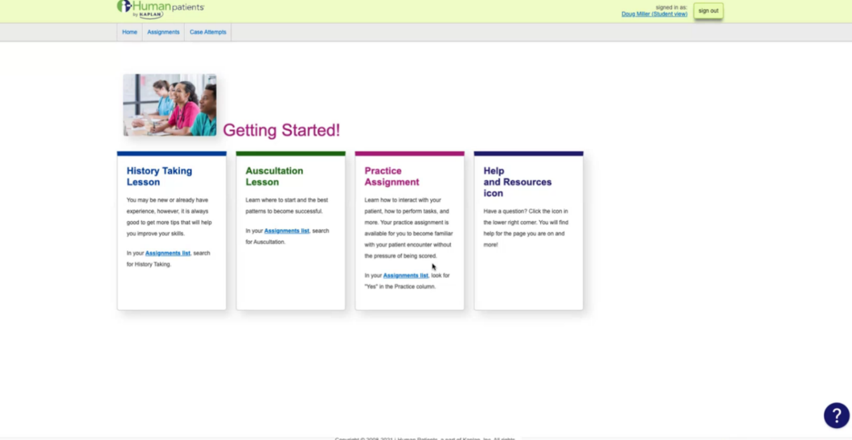

# Help and Resources Page

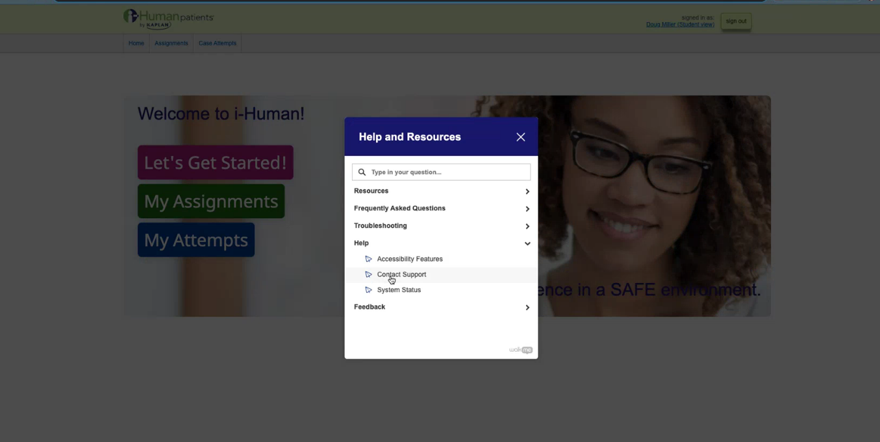

If you click **Customer Support**, the Customer Support Page opens.

# Customer Support Page

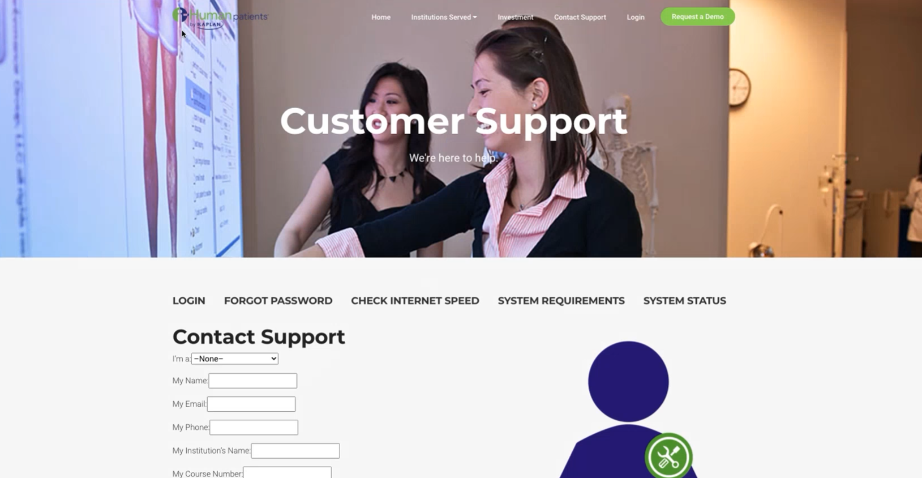

**Remember that you can access Help and Resources from anywhere in the**

**i-Human platform by clicking the question icon.**

# My Assignments

This tab will display the cases that are assigned to your course.

Image showing home screen with tabs: 
1. Let's get started
2. My Assignments
3. My Attempts