Clinical Course iHuman Documentation Guide

Use this guide to support documentation within the iHuman Virtual Patient Encounter. **All documentation for the client visit must be entered into the iHuman platform.**

**EHR Documentation**

Use the Electronic Health Record (EHR) to document pertinent information related to the history and physical exam. You can access and update the client record at any time while you are completing case play within the Human Virtual Platform clicking on the EHR button at the bottom of the screen. Click Return to Case to return to the client. Include pertinent information for the focused assessment using the tabs within the EHR.



**EHR Tips**

* Include a chief complaint (CC), or a BRIEF statement identifying why the client is presenting for care. Establishing the CC is the anchor to the entire visit documentation. Use the client’s own words (i.e., "headache", NOT "bad headache for 3 days”). It should be limited to 2-3 words. A client may have more than one complaint (i.e., if the client presents with cough and sore throat. Only one of the complaints will be the CC even if the patient has a list of complaints. As the provider, you must make this determination. What is the true reason for the visit and which symptom(s) is/are associated complaints? Associated complaints belong under the characteristics on the HPI.
* Use OLD CARTS (onset, location/radiation, duration, character, aggravating factors, relieving factors, timing, and severity) to document the history of present illness (HPI).
  + ONSET: Onset and duration are not the same. Onset is when the CC began. Be specific; “*7 days ago*” is more informative than “*about a week ago*”.
  + LOCATION: Location does not refer to geography. Think about where CC might “reside” in the body. If the CC was fatigue, the location would be “*Generalized*” as this complaint involves the entire body not just one system or location.
  + DURATION: Duration is an interval of time. For example, when does the pain begin? What time of day? How long does it last? How many episodes in 24 hours? What is the frequency?
  + CHARACTERISTICS: Characteristics refers to all associated symptoms and complaints. For example, if a patient presents with a cough and sore throat, you need to determine if the complaints are related, and which came first. Document the other symptom as “*associated with sore throat*.” If the CC is pain, what are the characteristics of the pain? Dull? Sharp? Radiating? etc.
  + AGGRAVATING FACTORS: Aggravating factors must be specific. For example, “*weight bearing*” is better than “*standing and walking*,” but you should also include other limitations if known to better understand the severity of the present illness, such as “*Unable to stand for more than 5 minutes*”.
  + RELIEVING FACTORS: Relieving factors must include details about the improvement or “relief.” For example, if Tylenol was reported to relieve pain, what was the new pain rating number?
  + TREATMENT: If a treatment resulted in relief of the CC (was a relieving factor), do not double chart it as a treatment again on the HPI. Include under treatment any intervention by the patient which did not help. If no other treatment was used, then document “*No other treatment*” and move on.
* Include all past medical history, medications, and allergies.
* Include reaction/response to each allergen.
* Include dosage, frequency, length of time used, and reason for use for each medication and over-the-counter (OTC) or complementary and alternative product.
* Limit documentation about preventive health, family, and social histories to findings pertinent to the HPI.
* Social history may include but is not limited to occupation and major hobbies, family status, tobacco and alcohol use, and any other pertinent data. Include healthy behaviors such as seat belt use all the time or functional smoke detectors in the house, etc.
* Family history may include but is not limited to illnesses with possible genetic predisposition, or contagious or chronic illnesses. The reason for the death of any deceased first-degree relatives should be included, for example, parents, grandparents, siblings, and children. Include grandchildren if pertinent.
* Address all body systems in the review of systems (ROS) that may help rule in or out a differential diagnosis. Limit ROS documentation to positive and negative findings pertinent to the focused health history. Describe findings; do not use WNL.
* The physical exam includes information gathered during the physical examination by inspection, palpation, auscultation, and percussion. Limit documentation to findings pertinent to the focused assessment based on the CC. If a pertinent body system is unable to be assessed, write “Unable to assess”. Document both pertinent positive and negative assessment findings. Pertinent positives are the “abnormal” findings and pertinent “negatives” are the expected normal findings. Separate the assessment findings accordingly and provide detail. Describe findings; do not use vague terminology, like “WNL”.

**Key Findings**

Add key findings at any time during the history or physical exam by clicking the **+ sign**. Organize key findings using the up and down arrows. Key findings will be further organized in the Assessment.

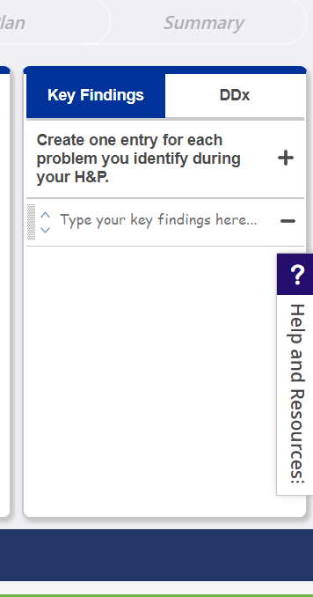

**Problem Statement**

Document a problem statement using professional language. Include pertinent demographic data, a brief description of the HPI and other pertinent subjective findings, and a brief description of pertinent objective findings. Use the data collected and documented in the EHR and summarize the data in the problem statement. Note that the problem statement has a 155-word limit. A sample problem statement is shown below.

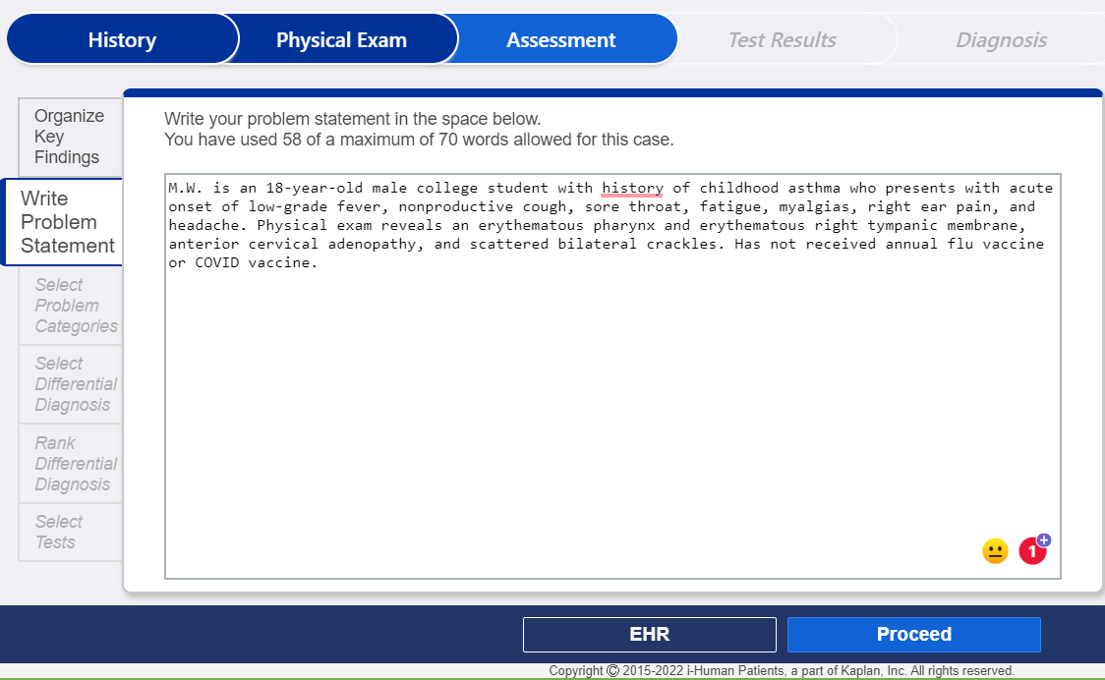

**Differential Diagnosis**

Select the most appropriate differential diagnoses from the provided list. Once you have selected your differentials, you will rank the diagnoses, select appropriate diagnostic tests, and then confirm the diagnosis.

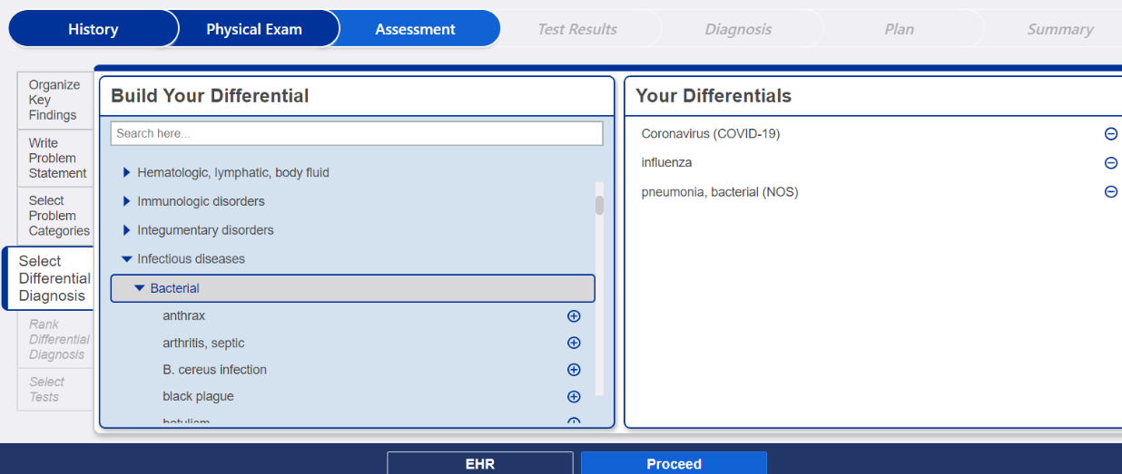

**Management Plan**

Use the diagnosis selected to create a comprehensive treatment plan using professional language. Use headings to address all five (5) components of the comprehensive treatment plan. If an intervention for any part of the treatment plan is not ordered, write “None at this time.” Be sure to address each area. No intervention is self-evident. Provide a rationale and scholarly in-text citation for each intervention. Include at least one appropriate, evidence-based, scholarly source to support the management decisions. A sample management plan for a client with allergic rhinitis is shown below.

Diagnostic Testing: No diagnostic testing is indicated at this time. Rationale: Sinonasal imaging does not play a role in the routine management of allergic rhinitis (Rose & Corrigan, 2022).

Medication(s): Nasonex Spray 50mcg Sig: 2 sprays in each nostril once daily. Disp: 1 sprayer RF: 0 Rationale: Steroid nasal sprays are the most effective medications to reduce and prevent nasal allergy symptoms. (Rose & Corrigan, 2022).

Referral/Consultation: None at this time. Rationale: Consider referral for allergy testing and immunotherapy if no response to treatment (Rose & Corrigan, 2022).

Education: Avoid allergens, if known and possible. Monitor pollen forecasts each day and be aware when the pollen count is high. Try to keep windows closed when pollen is being released in the early mornings, and in the evening when the air cools and pollens that have been carried up into the air begin to fall to ground level again. Instruct on proper use of nasal spray (Rose & Corrigan, 2022).

Follow-up: Return to the office in 14 days. Seek immediate attention if uncontrolled nosebleeds, fever greater than 102, severe headache, or confusion. Rationale: Steroid nasal sprays are used frequently with a low chance of side effects: Sometimes they may cause nasal dryness or nosebleeds, but this can generally be avoided by correct spray technique and by using saline sprays. Headache, fever, and confusion may indicate a new or worsening condition (Rose & Corrigan, 2022).

Reference:

Rose, R. M., & Corrigan, M. D. (2022). Clinical practice guideline (update): Allergic rhinitis. *American Academy of Family Physicians*, *152*(2), S1–S39. <https://doi.org/10.1177/0194599815572098>

**Management Plan Tips:**

* **Diagnostic tests**: Include the tests ordered in the management plan. Do not include results. A rationale or citation for diagnostic tests is not required.
* **Medications/treatments**: List medications/treatments and OTC drugs that will be ordered. Write“ continue meds” if pertinent. Include appropriate, evidence-based treatment recommendations. Explain the rationale for all decisions and provide support from scholarly sources with an in-text citation.
* **Consults/referrals**: Provide a list of appropriate referrals. Include a rationale for each and provide support from scholarly sources with an in-text citation.
* **Client education**: Provide documentation of appropriate client education. Include a rationale and provide support from scholarly sources with an in-text citation.
* **Follow-up**: Indicate when the client should return for care and provide detailed symptomatology indicating if the client should return sooner than scheduled or seek attention elsewhere.
* Include the full reference for all in-text citations used. Italics for journal titles are not required within iHuman documentation.
* Include 1-2 scholarly references for the management plan. Each reference must support the selection of interventions and guide clinical decision-making. The best references are national guidelines or treatment protocols. The textbook may be used in addition to an evidence-based, scholarly source.
* Consider completing the management plan within a Word document and copy/paste it to the iHuman Plan tab when complete.