iHuman Documentation Guide

**Use this guide to complete documentation within the iHuman Virtual Patient Encounter. All documentation for the virtual patient encounter must be entered into the iHuman platform.**

# Patient Record Documentation

Use the Patient Record to document pertinent information related to the history and physical exam. Access and update the patient record any time during the patient encounter by clicking on the Show Patient Record button. Click the Hide Patient Record button to return to your patient.

  

Include pertinent information for the focused assessment using the tabs within the patient record: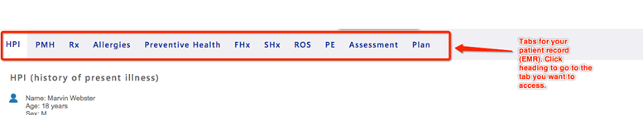

# Tips for Documenting in the Patient Record

* Chief complaint (CC) is a BRIEF statement identifying the reason for the patient encounter using the patient’s own words, i.e., "my head hurts", NOT "bad headache for 3 days”. If a patient has more than one complaint, identify which complaint is the CC and which may be an associated symptom.
* Use OLD CARTS to document the history of present illness (HPI).
* Include all past medical history, medications, and allergies.
* Include reaction/response to each allergen.
* Include dosage, frequency, length of time used, and the reason for use for each prescribed medication, over-the-counter medication (OTC), or homeopathic products.
* Limit preventive health, family, and social history to findings pertinent to the HPI.
* Social history documentation may include is but is not limited to occupation and major hobbies, family status, tobacco and alcohol use, and other pertinent data. Include health promotion strategies such as consistent seat belt use or functional smoke detectors in the house.
* Family history documentation may include but is not limited to illnesses with possible genetic predisposition, contagious, or chronic illnesses. The reason for the death of any deceased first-degree relatives should be included (parents, grandparents, siblings, and children). Include grandchildren if pertinent.
* Review of systems (ROS) documentation should include all body systems that may help rule in or out a differential diagnosis. Limit ROS documentation to pertinent positive and negative findings relevant to a focused health history. Describe findings; do not use WNL.
* Physical examination documentation should include data obtained by inspection, palpation, auscultation, and percussion. Limit documentation to findings pertinent to the focused assessment based on the client’s chief complaint. If a pertinent body system is not accessible, write “Unable to assess”. Document pertinent positive and negative assessment findings. Pertinent positive findings include the “abnormal” findings; pertinent “negative” findings include the expected normal findings. Separate the assessment findings accordingly and provide detail for each finding. Describe findings; do not use WNL.

# Key Findings

Add key findings at any time during the history or physical exam by clicking the + sign. Key findings may be organized using the up and down arrows. Organize the key findings further in the Assessment step.

# Problem Statement

Problem Statement: Document a problem statement using professional language. Include pertinent demographic data, a brief description of the HPI and other pertinent subjective findings, and a brief description of pertinent objective findings. Use the data collected and documented in the patient record and summarize the data in the problem statement. Note that the problem statement has a 155-word limit. A sample problem statement is shown below.

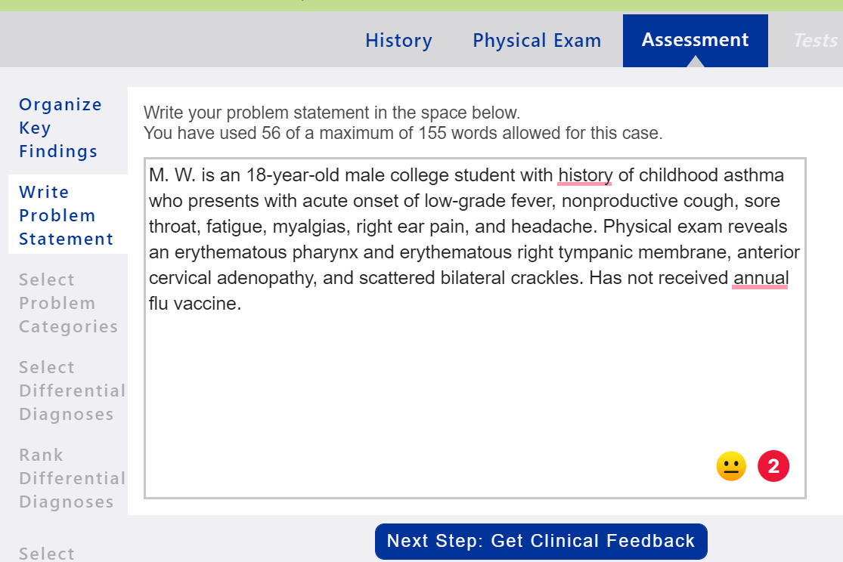

# Management Plan

Using the expert diagnosis provided, create a comprehensive treatment plan using professional language. Use headings to address all five (5) parts of the comprehensive treatment plan. If an intervention is not ordered for any part of the treatment plan, write “None at this time”; address each area. No intervention is self-evident. Provide a rationale and evidence-based in-text citation for each intervention. Include at least one appropriate, evidence-based, scholarly source to support decision-making. A sample management plan is shown below.

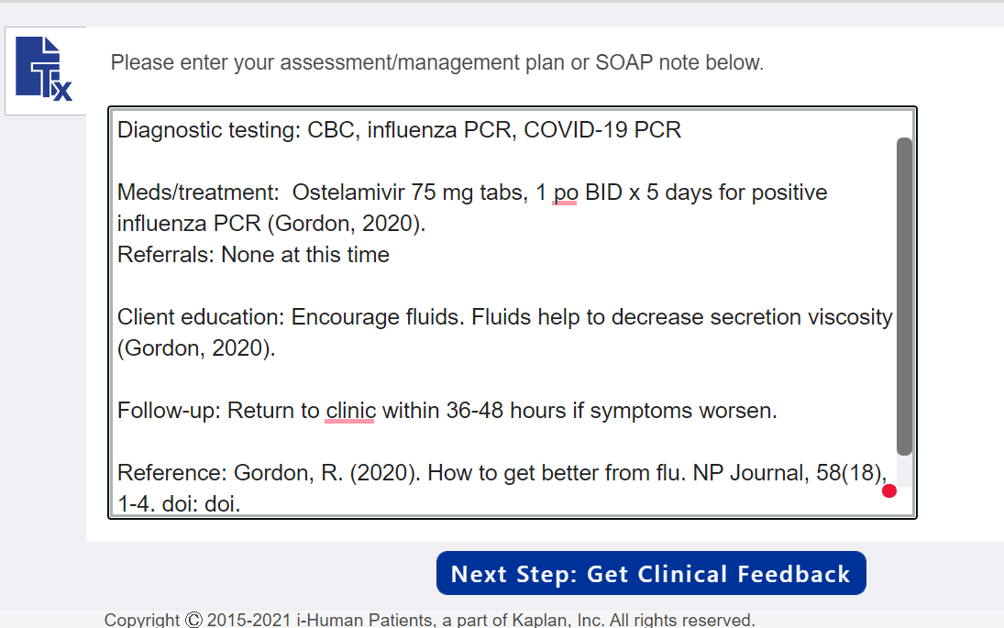

# Tips for Developing a Management Plan

* Diagnostic tests: Include the tests ordered in the management plan. Do not include results.
* Medications/treatments: List medications/treatments including OTC drugs you will order and “continue meds” if pertinent. Include appropriate, evidence-based treatment recommendations. Explain the rationale for all decisions and provide support from scholarly literature with an in-text citation.
* Consults/referrals: Provide a list of appropriate referrals. Include a rationale for each and provide support from scholarly literature with an in-text citation.
* Client education: Provide documentation of appropriate client education. Include a rationale and provide support from scholarly literature with an in-text citation.
* Follow-up: Indicate when the patient should return for care and provide detailed symptomatology indicating if the patient should return sooner than scheduled or seek attention elsewhere.
* Include a full matching reference for all in-text citations. Italics and hanging indents cannot be used within iHuman documentation.
* Include 1-2 scholarly references for the SOAP note. Each reference must support the selected interventions and guide clinical decision-making. The best references are national guidelines or treatment protocols.
* Complete the SOAP note in a Word document and copy/paste it into the iHuman Plan tab.