**NR305 Week 2 iHuman Nurse Notes Template**

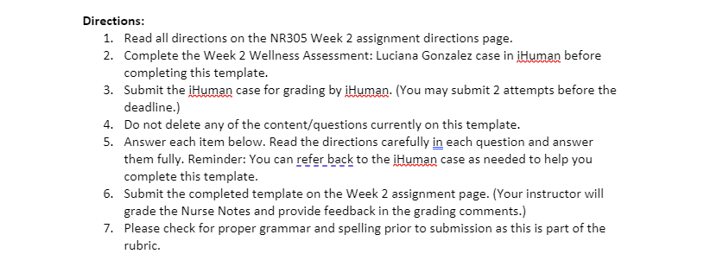**Name**: **Date:**

***Complete each item below***:

1. Write an SBAR note (Situation, Background, Assessment, Recommendations) to summarize this assessment. Hint: Since this is a wellness assessment your summary should include a comprehensive, but brief, review of all of your findings, not only abnormal results. To develop your note, **type the appropriate information after each letter below**.

S –

B –

A –

R -

1. State at least three additional assessment questions you would like to ask Ms. Gonzalez.

3. In a one paragraph response, what made you select these questions?
4. State two priority opportunities for health promotion and/or disease prevention for Ms. Gonzalez.

7. In a one paragraph response, **what assessment findings in iHuman** led you to select the two opportunities you have identified? Utilize the optional assigned readings, course lessons, or an outside scholarly source of your choice to support your thoughts and ideas. **Cite** your resources in your paragraphs and **list your reference(s)** after your response.