POWERPOINT NOTES PAGE IN PDF FORMAT
JOB AID

In order for faculty to easily view the speaker notes of a PowerPoint, you may be asked to submit the PowerPoint in PDF format. Here are the steps:

For a Windows PC:

Open your Powerpoint. Verify that the speaker notes are present below the slide. Click on File.

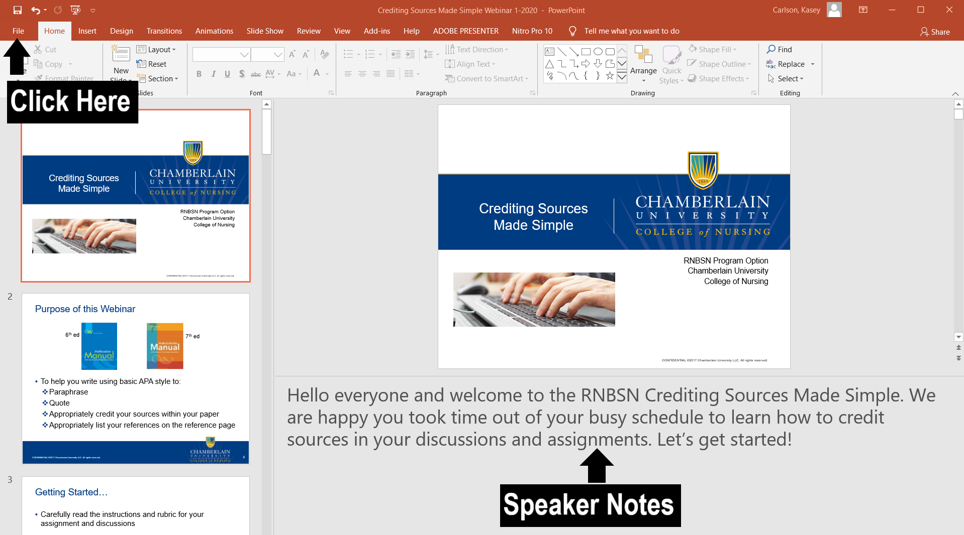

Option 1: Print to PDF

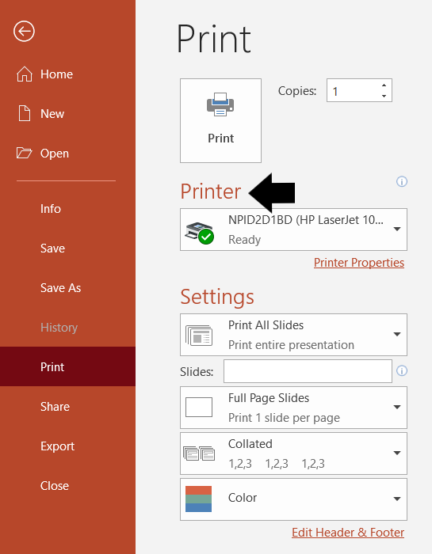
Step 1: Under File, scroll down and click on Print. Find Printer.

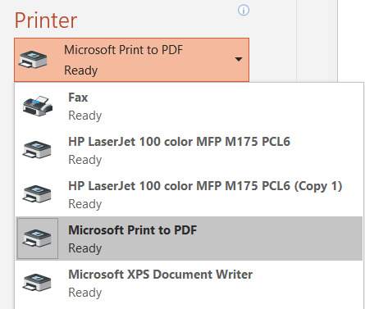
Step 3: Click on the drop down options under Printer. Select Print to PDF.

Step 4: Under Settings, select Print All Slides.
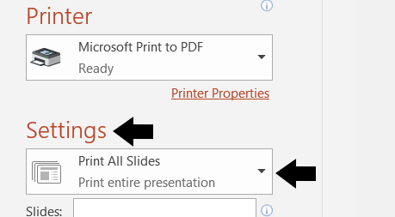

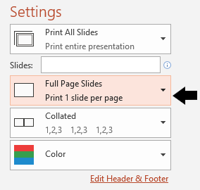
Step 5: Under Settings below Print All Slides, click on Full Page Slides and change it to Notes Pages
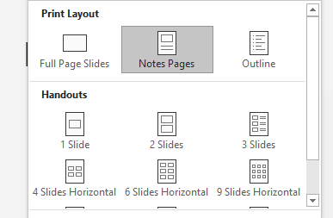

Step 6: Click on Print. Name your new PDF document and Save it to a location on your computer. Note: Some courses request a specific name. Please see assignment directions for naming of your document.
Option 2: Export to PDF

Step 1: Under File, scroll down and click on Export. Find Create PDF/XPS Document. Click on box.
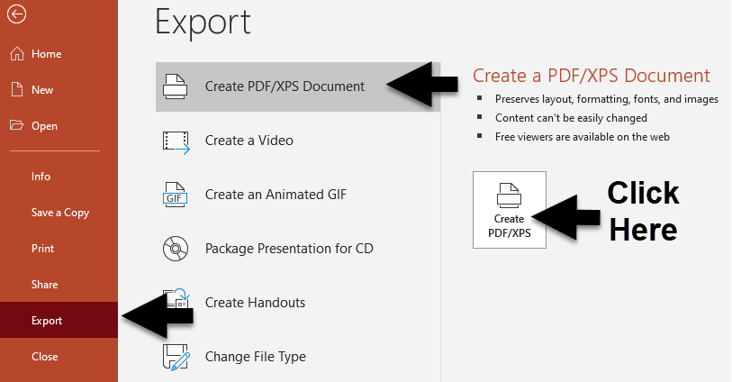

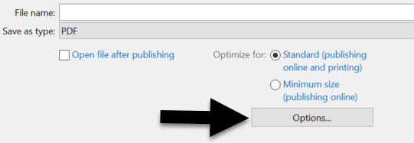
Step 2: Before saving, click Options.

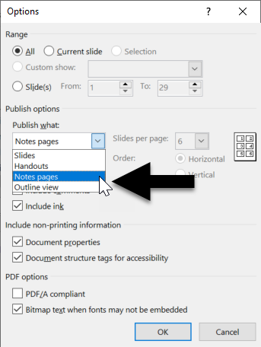

Step 3: Under “Publish what:”, select Notes Pages. Click OK.

Step 4: Name your new PDF document and Save it to a location on your computer. Note: Some courses request a specific name. Please see assignment directions for naming of your document.

Final Step of Either Option: Return to the assignment page in Canvas to submit your PDF file.

For a MAC PC:

Step 1: Open your Powerpoint. Verify that the speaker notes are present below the slide. Pull down File and scroll down to Print.

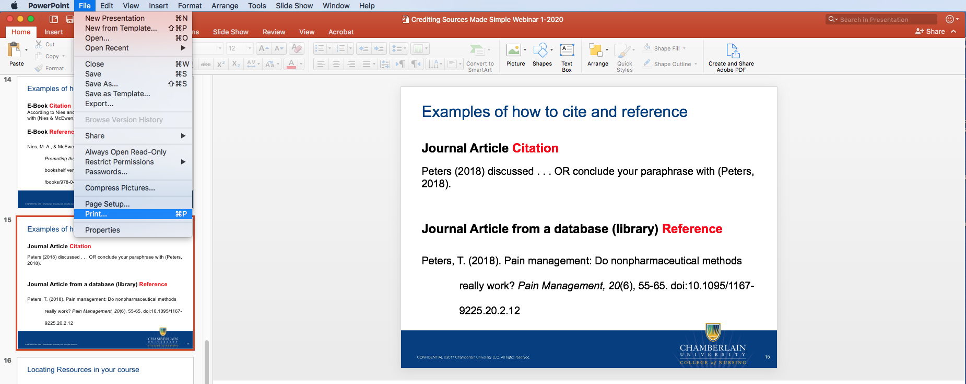

Step 2: Under Layout, find and select Notes. Choose Orientation,
portrait or landscape.
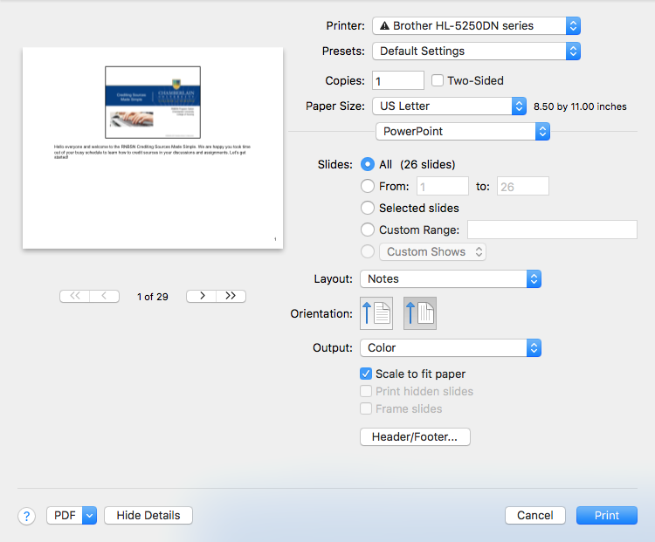

Step 3: Open PDF (bottom left), select Save as PDF.
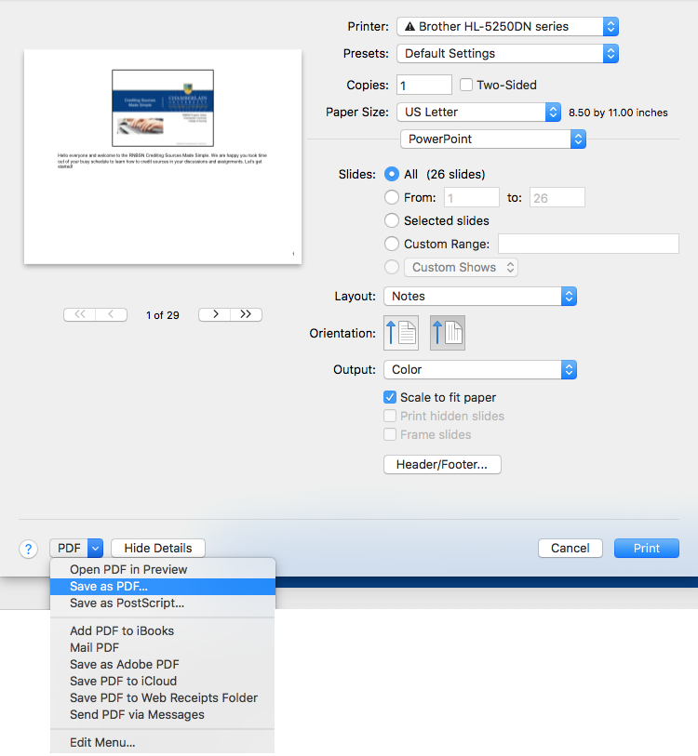

Step 4: Name your new PDF document and Save it to a location on your computer.
Note: Some courses request a specific name. Please see assignment directions for naming of your document.

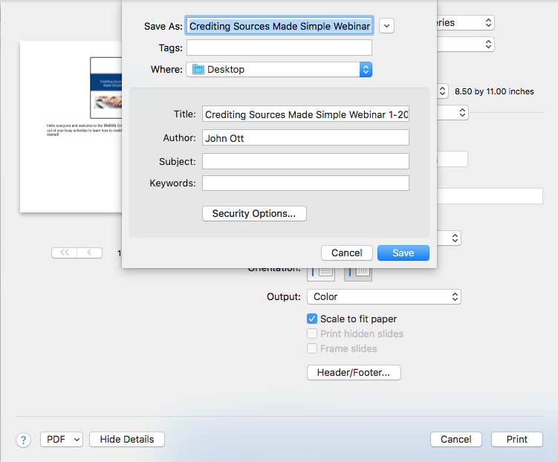

Step 5: Return to the assignment page in Canvas to submit your PDF file.

