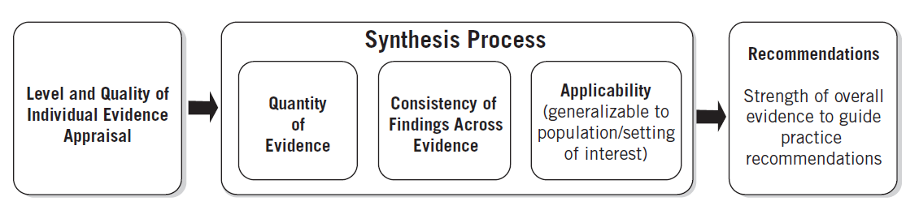

**Key Points:**

* Evidence synthesis is best done through group discussion. All team members share their perspectives, and the team uses critical thinking to arrive at a judgment based on consensus during the synthesis process. The synthesis process involves both subjective and objective reasoning by the full EBP team.

Through reasoning, the team:

* Reviews the quality appraisal of the individual pieces of evidence
* Assesses and assimilates consistencies in findings
* Evaluates the meaning and relevance of the findings
* Merges findings that may either enhance the team’s knowledge or generate new insights, perspectives, and understandings
* Highlights inconsistencies in findings
* Makes recommendations based on the synthesis process
* When evidence includes multiple studies of Level I and Level II evidence, there is a similar population or setting of interest, and there is consistency across findings, EBP teams can have greater confidence in recommending a practice change. However, with a majority of Level II and Level III evidence, the team should proceed cautiously in making practice changes. In this instance, recommendation(s) typically include completing a pilot before deciding to implement a full-scale change.
* Generally, practice changes are not made on Level IV or Level V evidence alone. Nonetheless, teams have a variety of options for actions that include, but are not limited to: creating awareness campaigns, conducting informational and educational updates, monitoring evidence sources for new information, and designing research studies.
* The quality rating (see Appendix D) is used to appraise both individual quality of evidence and overall quality of evidence.

|  |  |  |  |
| --- | --- | --- | --- |
| **EBP Question:** Enter text. | | | |
| **Category (Level Type)** | **Total Number of Sources/Level** | **Overall Quality Rating** | **Synthesis of Findings Evidence That Answers the EBP Question** |
| **Level I**   * Experimental study * Randomized controlled trial (RCT) * Systematic review of RCTs with or without meta-analysis * Explanatory mixed method design that includes only a Level I quaNtitative study | Total Number. | Overall Rating | Findings. |
| **Level II**   * Quasi-experimental studies * Systematic review of a combination of RCTs and quasi-experimental studies, or quasi-experimental studies only, with or without meta-analysis * Explanatory mixed method design that includes only a Level II quaNtitative study | Total Number. | Overall Rating | Findings. |
| **Level III**   * Nonexperimental study * Systematic review of a combination of RCTs, quasi-experimental and nonexperimental studies, or nonexperimental studies only, with or without meta- analysis * QuaLitative study or meta- synthesis * Exploratory, convergent, or multiphasic mixed-methods studies * Explanatory mixed method design that includes only a level III QuaNtitative study | Total Number. | Overall Rating | Findings. |

|  |  |  |  |
| --- | --- | --- | --- |
| **Category (Level Type)** | **Total Number of Sources/Level** | **Overall Quality Rating** | **Synthesis of Findings Evidence That Answers the EBP Question** |
| **Level IV**   * Opinions of respected authorities and/or reports of nationally recognized expert committees or consensus panels based on scientific evidence | Total Number. | Overall Rating | Findings. |
| **Level V**   * Evidence obtained from literature or integrative reviews, quality improvement, program evaluation, financial evaluation, or case reports * Opinion of nationally recognized expert(s) based on experiential evidence | Total Number. | Overall Rating | Findings. |

|  |
| --- |
| Based on your synthesis, which of the following four pathways to translation represents the overall strength of the evidence? |
| **Strong, compelling evidence, consistent results**: *Solid indication for a practice change is indicated.*  **Good and consistent evidence**: *Consider pilot of change or further investigation.*  **Good but conflicting evidence**: No indication for practice change; consider further investigation for new evidence or develop a research study.  **Little or no evidence**: No indication for practice change; consider further investigation for new evidence, develop a research study, or discontinue project. |
| *If you selected either* ***Strong, compelling evidence, consistent results or Good and consistent continue****. If not,* ***STOP****, translation is not indicated.* |
| Recommendations based on evidence synthesis and selected translation pathway |
| Recommendations |
| Consider the following as you examine fit: |
| Are the recommendations:   * Compatible with the unit/departmental/organizational cultural values or norms? * Consistent with unit/departmental/organizational assumptions, structures, attitudes, beliefs, and/or practices? * Consistent with the unit/departmental/organizational priorities? |
| Consider the following as you examine feasibility: |
| * Can we do what they did in our work environment? * Are the following supports available? * Resources * Funding * Approval from administration and clinical leaders * Stakeholder support * Is it likely that the recommendations can be implemented within the unit/department/organization? |

Directions for Use of This Form

# Purpose of form

Use this form to compile the results of the individual evidence appraisal to answer the EBP question. The pertinent findings for each level of evidence are synthesized, and a quality rating is assigned to each level.

# Total number of sources per level

Record the number of sources of evidence for each level.

# Overall quality rating

Summarize the overall quality of evidence for each level. Use Appendix D to rate the quality of evidence.

# Synthesis of findings: evidence that answers the EBP question

* Include only findings from evidence of A or B quality.
* Include only statements that directly answer the EBP question.
* Summarize findings within each level of evidence.
* Record article number(s) from individual evidence summary in parentheses next to each statement so that the source of the finding is easy to identify.

# Develop recommendations based on evidence synthesis and the selected translation pathway

Review the synthesis of findings and determine which of the following four pathways to translation represents the overall strength of the evidence:

* Strong, compelling evidence, consistent results: Solid indication for a practice change.
* Good and consistent evidence: Consider pilot of change or further investigation.
* Good but conflicting evidence: No indication for practice change; consider further investigation for new evidence or develop a research study.
* Little or no evidence: No indication for practice change; consider further investigation for new evidence, develop a research study, or discontinue the project.

# Fit and feasibility

Even when evidence is strong and of high quality, it may not be appropriate to implement a change in practice. It is crucial to examine feasibility that considers the resources available, the readiness for change, and the balance between risk and benefit. Fit refers to the compatibility of the proposed change with the organization’s mission, goals, objectives, and priorities. A change that does not fit within the organizational priorities will be less likely to receive leadership and financial support, making success difficult. Implementing processes with a low likelihood of success wastes valuable time and resources on efforts that produce negligible benefits.