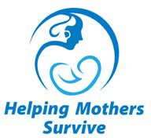
Helping Mothers Survive
Vacuum-Assisted Birth
Knowledge Assessment
Answer Key

C
B
C
C
A
D
A
B
C
A
D
B
A
D
B
A
B
B
B
B

