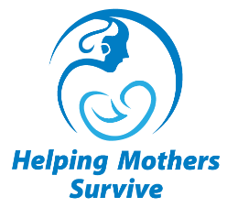
Helping Mothers Survive
Vacuum-Assisted Birth
Confidence Assessment

Participant ID# ___________________ Date ___________________

Is this a pre-training or post-training assessment? (Circle one.)
- Pre-training assessment
- Post-training assessment

INSTRUCTIONS: For each question, circle 1 best response

- How confident are you in your ability to perform an assessment of a woman with suspected prolonged second stage of labor to identify the cause?
- Not at all confident
- Not very confident
- Somewhat confident
- Very confident
- Extremely confident

- How confident are you in your ability to perform an assessment of women with indications for a vacuum-assisted birth to ensure that she meets criteria?
- Not at all confident
- Not very confident
- Somewhat confident
- Very confident
- Extremely confident

- How confident are you in your ability to identify women who are candidates for a VAB?
- Not at all confident
- Not very confident
- Somewhat confident
- Very confident
- Extremely confident

- How confident are you in your ability to conduct a vacuum-assisted birth?
- Not at all confident
- Not very confident
- Somewhat confident
- Very confident
- Extremely confident

- How confident are you in your ability to examine a newborn for injuries after the woman has had a vacuum-assisted birth?
1. Not at all confident
2. Not very confident
3. Somewhat confident
4. Very confident
5. Extremely confident

