
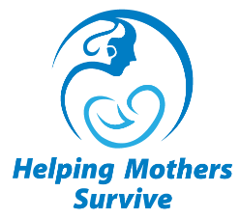
Helping Mothers Survive
Essential Care for Labor & Birth
Trainer Evaluation

Date ____________

Instructions: For each question, circle the number that corresponds to how much you agree or disagree with the statement.

Please add any comments on the back of this form.

PLEASE EVALUATE EACH STATEMENT | Disagree Agree
The concept of HMS ECL&B is clear to me. | 1 2 3 4 5
I am confident I can use the Flipbook to train providers. | 1 2 3 4 5
I am confident I can use the Action Plan. | 1 2 3 4 5
I am confident that I can explain the use of the Provider’s Guide to participants. | 1 2 3 4 5
I am confident I can role model respectful maternity care. | 1 2 3 4 5
I am confident in my ability to use role plays, simulation, and hands-on practice during training. | 1 2 3 4 5
The goal and schedule of low-dose, high-frequency practice and QI activities are clear to me. | 1 2 3 4 5
I believe that I can provide the HMS ECL&B Champions course to train others. | 1 2 3 4 5

