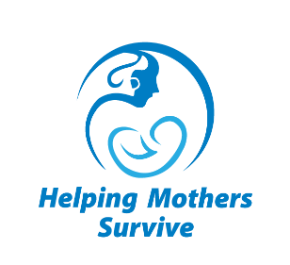**Helping Mothers Survive**

**Vacuum-Assisted Birth**

**Practice Coordinator Orientation Evaluation**

Date ____________

**Instructions**: For each question, circle the number that corresponds to how much you agree or disagree with the statement.

Please add any comments on the back of this form.

|  |  |
| --- | --- |
| **PLEASE EVALUATE EACH STATEMENT** | **Disagree Agree** |
| I am confident in my ability to use the Action Plan. | 1 2 3 4 5 |
| I am confident that I can use the Provider’s Guide to help my peers practice. | 1 2 3 4 5 |
| The goal and schedule of low-dose, high-frequency practice and QI activities are clear to me. | 1 2 3 4 5 |
| I clearly understand how to work with the team to evaluate progress made in achieving SMART objectives and make new objectives as needed. | 1 2 3 4 5 |
| I am confident in my ability to role model respectful maternity care. | 1 2 3 4 5 |
| I clearly understand how to prepare for LDHF practice sessions. | 1 2 3 4 5 |
| I am confident in my ability to use role-plays, simulation, and hands-on practice for facilitating LDHF activities for HMS VAB scenarios. | 1 2 3 4 5 |
| I am confident I can facilitate practice for HMS at my facility. | 1 2 3 4 5 |
| This orientation was useful to me. | 1 2 3 4 5 |