
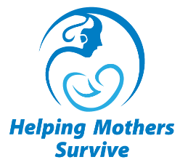
Helping Mothers Survive
Essential Care for Labor & Birth
Participant Evaluation

Date ____________

Instructions: For each question, circle the number that corresponds to how much you agree or disagree with the statement.

Please add any comments on the back of this form.

PLEASE EVALUATE EACH STATEMENT | Disagree Agree
The concept of Helping Mothers Survive ECL&B is clear to me | 1 2 3 4 5
I understand how to use the Action Plan. | 1 2 3 4 5
I understand how to use the Provider’s Guide. | 1 2 3 4 5
I understand how to classify women as in active labor or not. | 1 2 3 4 5
I understand how to classify women as in normal or not. | 1 2 3 4 5
I understand the frequency of monitoring women in labor. | 1 2 3 4 5
I know how to prepare for birth. | 1 2 3 4 5
I am comfortable assisting women to choose positions for labor and pushing. | 1 2 3 4 5
I am confident managing a clean and safe birth. | 1 2 3 4 5
I am comfortable assisting women to give birth in various positions. | 1 2 3 4 5
It is clear to me the goal and importance of low dose, high frequency practice and quality improvement activities after training. | 1 2 3 4 5
This training will help me improve the care I provide to women. | 1 2 3 4 5
Simulated practice was helpful to me for learning how to assess, monitor and deliver women in labor. | 1 2 3 4 5

